Human Body System Study Notes:

- Endocrine System

Four main structures:
- Glands: make and send hormones through the bloodstream
- Bloodstream: carries the hormones to a specific place
- Hormones: chemical messages made by glands which carry instructions
- Receptors: one specific receptor site for each hormone message

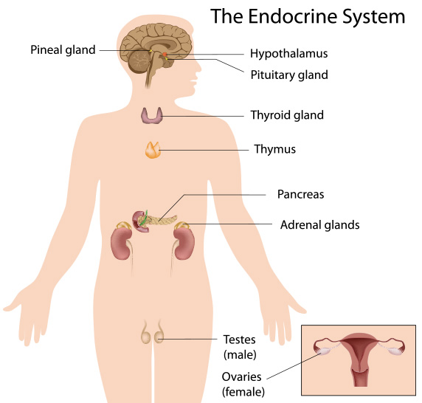

Two main communication pathways in your body- nervous system and endocrine system
- In general, the endocrine system is in charge of body processes that happen slowly, such as cell growth, hunger, digestion, mood, reproductive processes. Faster processes like breathing and body movement are controlled by the nervous system.

- Nervous System

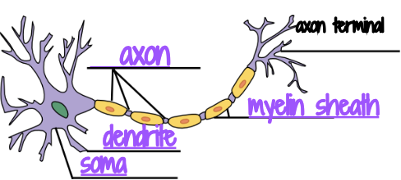

- Neurons transmit signals between different parts of the body
- Dendrites receive messages from other neurons
- Central nervous system is composed of the brain and spinal cord

- Digestive System
- Intestines absorb useable food substances
- Stomach receives food, churns it, and adds gastric juices
- The liver produces bile

Body part | Human digestion process | Bread in bag experiment
Mouth/ teeth | Food broken down into smaller pieces by the teeth | Tearing bread into smaller pieces
Stomach | Food submerged in the HCI of the stomach- chemical digestion | Add water into the bag
 | Mechanical Digestion by the stomach | Squish the bread with your fingers
Intestines | Water and vitamins are reabsorbed by the large intestine | Drain liquid from bag with paper clip
Rectum | Waste temporarily stored in the rectum | Put the contents of the bag into the garbage

- Circulatory System

- Largest artery is the aorta
- The superior/inferior vena cava carry blood from the upper and lower parts of the body
- Valves keep blood from flowing back
- Three blood vessels:
  - Arteries: carries blood away from the heart
  - Veins: carries blood to the heart
  - Capillaries: transfers oxygen and other nutrients from the bloodstream to other tissues

- Respiratory System
- Diaphragm is the dome-shaped sheet of muscle and tendon that serves as the main muscle of respiration
- Trachea is the windpipe that directs air to the lungs
- The medulla oblongata regulates respiration
- The alveoli allow oxygen and carbon dioxide to move between the lungs and bloodstream
- Our muscles need more oxygen when we exercise because muscles need oxygen to form ATP(energy) and exercising depletes oxygen reserves in the body

- Excretory(urinary) System
- Kidneys filter waste from the blood
- The ureter connects the kidneys to the urinary bladder
- Two functions of the excretory(urinary) system- removes waste from the blood, and regulates the concentration of body fluids
- If kidneys fail you might have to go to a hospital to have a dialysis machine clean your blood
- Structures that make up the system:
  - Kidneys, ureters, bladder, veins, arteries, internal sphincter, urethra)

