Human Body System Study Sheet

Nervous System:
- The Nervous System is the control centre for the entire body. It is made up of the brain, spinal cord, and neurons.
- Neurons, or nerve cells are specialized cells that make up your nervous system.
- Neurons carry electric signals called impulses from one part of the body to another. Dendrites receive impulses while axons carry impulses away from the cell body. The myelin sheath speeds up transmission.
- All neurons carry information from one part of your body to another. Sensory neutrons transmit signals from sense organs to the spinal cord and brain. Motor neurone transmit signals from your central nervous system to your muscles, telling them to move. Interneurons are messengers between the two neurons.

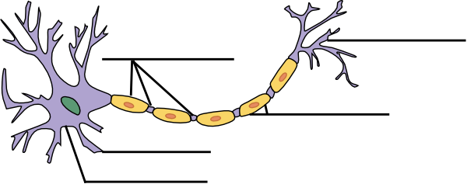

- The two components of the Nervous System are the Central Nervous System and the Peripheral Nervous System
- Central Nervous System- brain and spinal cord.
- Peripheral Nervous System- Somatic Nervous System and Autonomic Nervous System.

Endocrine System:
- Endocrine Gland: A gland in the body which secretes hormones into the bloodstream.
- Hormone: A chemical secreted by endocrine glands which carries instructions to the body. It has a high level of specificity, which means that it will only react with a specific receptor site in your body.
- Receptor: A specific site on a cell designed to recognize and accept a specific hormone.

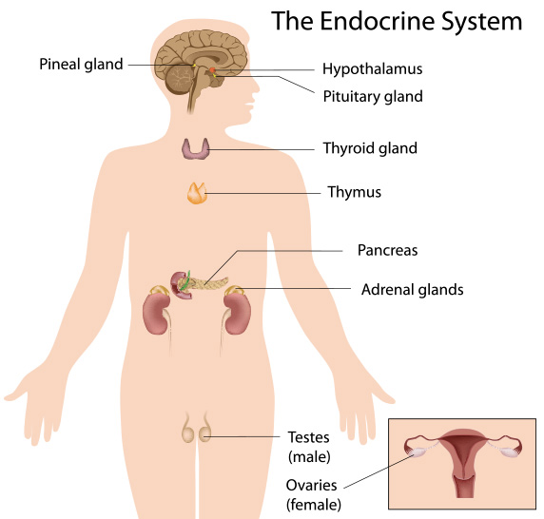

- Some body functions that are triggered by hormones include hunger, digestion, mood, muscle growth, “fight or flight” reflex, and reproductive processes.
- In general, the Endocrine System is in charge of body processes that happen slowly, such as cell growth.
- The Endocrine and Nervous System are separate systems, but often work together to help the body function properly.

Resources:

- http://video.nationalgeographic.com/video/101-videos/human-body-sci?source=relatedvideo
- https://www.youtube.com/watch?v=fHRC8SlLcH0 (Nervous System)
